University of Pittsburgh at Johnstown

Electrical and Computer Engineering Department SENIOR DESIGN COE1199

Cycle Statistic Tool

Weekly Memorandum
To: | Maddumage Karunaratne
From: | Jacob Hoffman  Cody Klingler

cc:
Date: | 03/08/2021

Re:

Achievements:

Cody: Cody successfully mounted and soldered 2 strain gauges on the crank arm and retrieved a signal from them. Miscellaneous components were also ordered. This includes wires, a box to contain the primary microcontroller, and the 2nd battery.

Jacob: The SQLite database was re-designed. Subsequently, Jacob set up a view model component for the application. The view model implements properties and commands that the view can data bind to. Additionally, the view model will notify the view of any state changes. Using the view model will allow for changes to occur automatically across all the views in the application.

Issues Encountered and Solved:

Cody: None.

Jacob: We were having some issues with changes being made to the data model not being updated on all views automatically. This was resolved by developing the data view model. The view model contains observable collections that mirror the current state of the data within the app’s databases. The view model also contains any bindable properties we would like to create, such as a variable to store an input received from the user.

Issues Encountered and Unresolved:

Cody: The signals from the strain gauge circuit are too noisy to retrieve meaningful measurements. A separate circuit may be used to amplify the analog signal and convert it to digital. One of the ones that we may use is the MX711 - Load Cell Amplifier.

Jacob: None.

Goals and Tasks For Next Week:

Cody: The strain gauge circuit needs to be made readable either by making the signal less noisy or by implementing an amplifier. A function in the arduino code needs to be made to convert floats to strings for use in the display. Bluetooth transmission between the mobile app and primary arduino needs to be tested.

Jacob: The performance view and trip view both need to be set up. The performance view will provide graphs and charts based on a collection of recorded trips. Each trip will also have a statistics view that can be launched, which will display all the recorded data about the selected trip. Additionally, the bluetooth connection and data collection need to be implemented so the user may establish a connection to the Cycle Statistic Tool and subsequently record a trip. This will conclude the requirements for the trip page.

Project Schedule:

Cody: Hardware paths are on schedule. Strain gauge issues could put us behind, but for now we are fine.

Jacob: The mobile application path is on schedule.

Project Logbook:

Cody:

03/03/2021 - 4.5 hours
Mounted 3 strain gauges onto the new crank arm. One strain gauge had a wrinkle that may have been caused by excess catalyzer. This strain gauge measured 346 Ohm rather than 350 Ohm and was later removed.

03/05/2021 - 1 hour
Ordered 2nd lithium battery, a box to encase the display and primary microcontroller, proto boards, and some wire. ~$45

03/07/2021 - 5 hours
Soldered the 2 strain gauges that were mounted properly. One of the leads was destroyed during soldering, so another strain gauge had to be mounted. This leaves us with 2 spare strain gauges. The strain gauges were soldered and assembled in a circuit. Retrieving values from the circuit yielded an extremely noisy signal.

Jacob:

03/01/2021 - 4 hours
The project team finished preparing for the monthly presentation. Additionally, the project team made changes to the weekly memo.

03/06/2021 - 4 hours
Development of a view model for interacting with the application’s data began. The view model implements properties and commands that the view can data bind to. Additionally, the view model will notify the view of any state changes. The application is following the Model-View-ViewModel (MVVM) design pattern. I spent a decent amount of time researching appropriate ways of implementing MVVM in xamarin/c#.

03/07/2021 - 3 hours
I continued to develop the view model. This included setting up commands for adding/removing/updating the data models and binding these commands to buttons on the user’s display. I’ve basically converted old code on the goal profile page so far. Using the view model will allow for changes to occur automatically across all the views in the application.

Task Division:

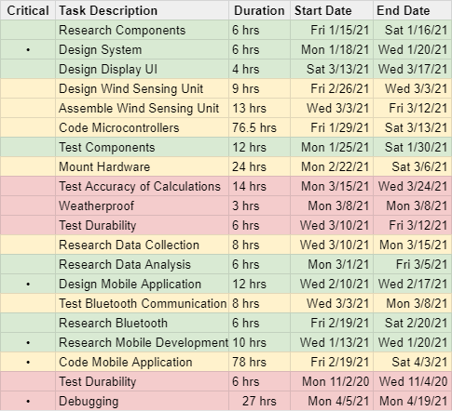
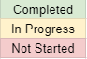

GANTT Chart:

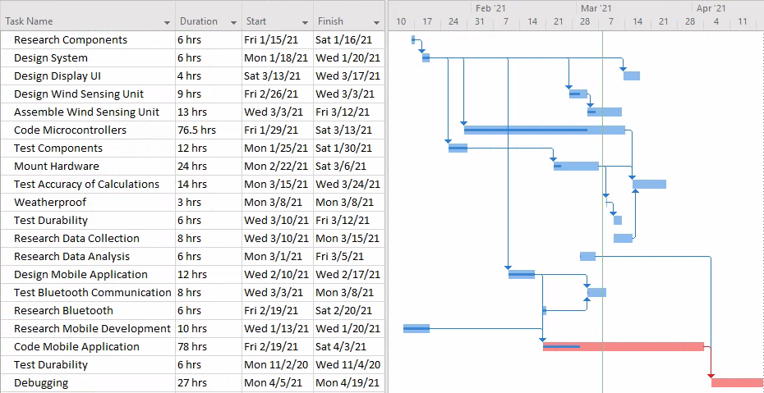

Bill of Materials:

